**LAB SESSION 10**

**PREPARED BY MUHAMMAD FARAZ ANSAR**

* **BCD-DECADE COUNTER:**
* **AT 3RD CLOCK**

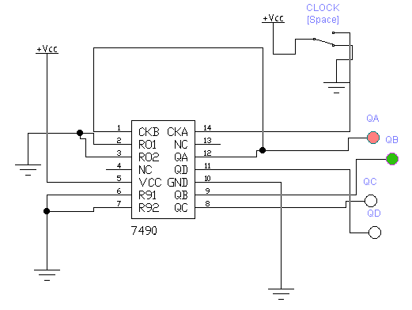

* **BI-QUINARY DECADE COUNTER:**

